- Change the official Student council member official roster
& in alumni of fame add these 2 linkedin’s & 1 of yours linkedin or git 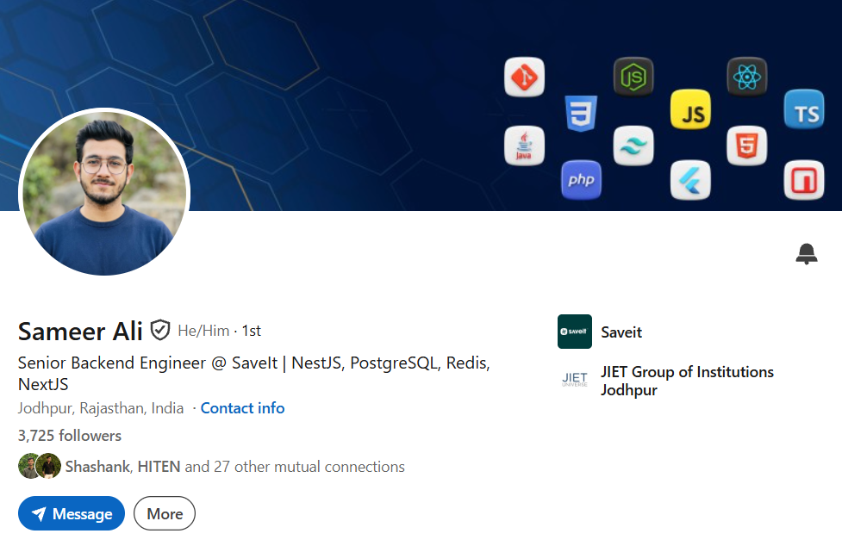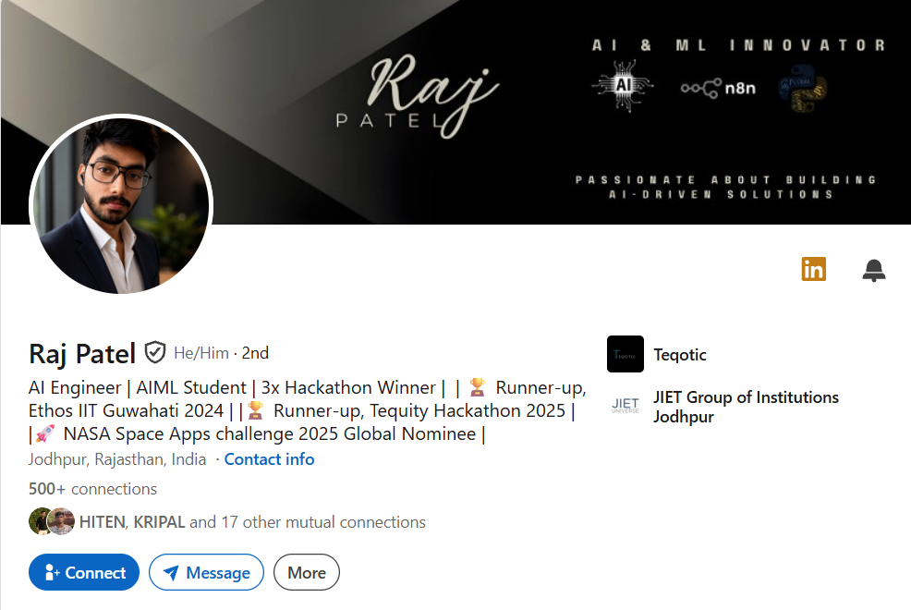
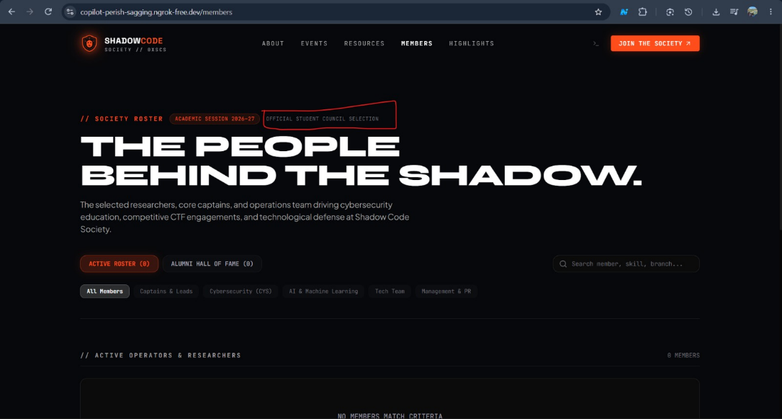
- Add update / competition currently happening
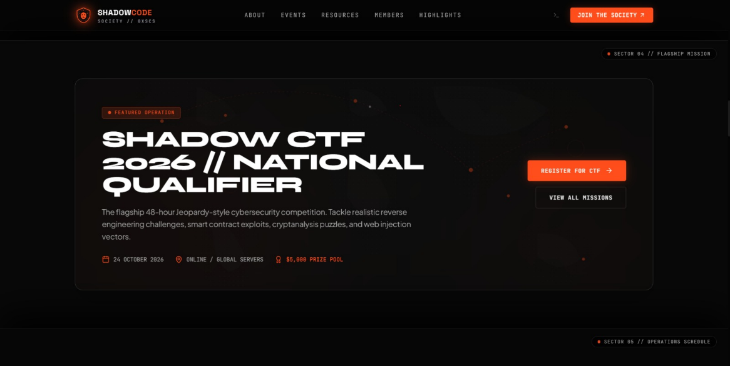

- Add Founding President (Rudra)& Faculty(Sohaib Khan Sir)
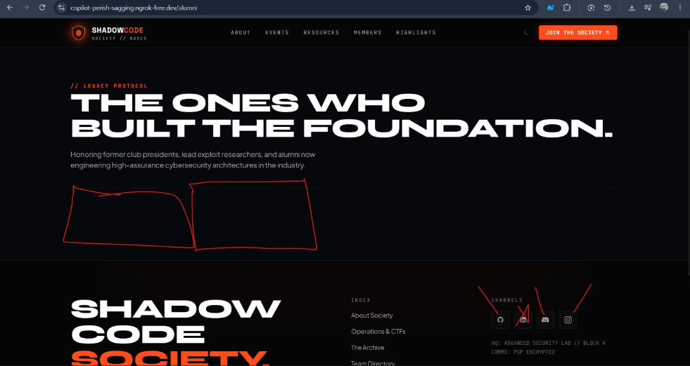

- Add our currently planned event at priority Cyber Hunt
& put Cloud security workshop to next yr
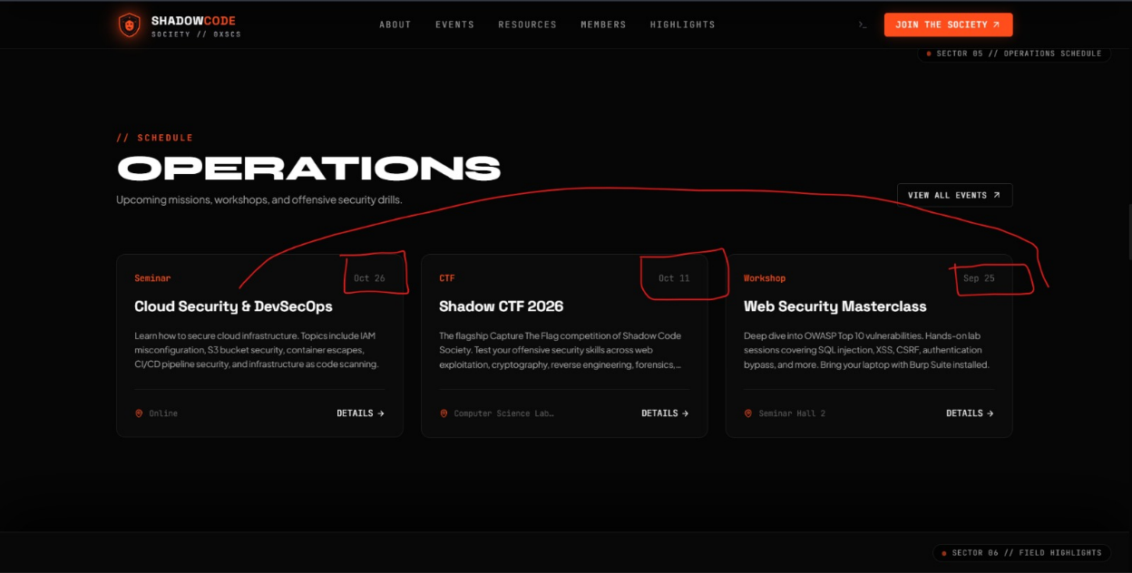

- Change CSE Admin
remove ethical hacking
remove session 2026 - 2027

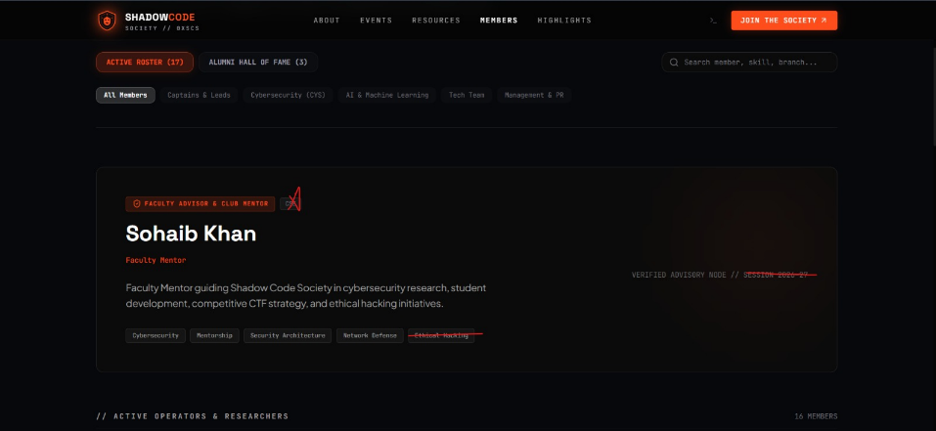
- Update members lists
Lakshya Siyota is from CSE 3rd yr (tech & management)
Riddhi Gandhi is from ai/ml 3rd yr(social media & PR)
show vaibhav & komal ko bhi lead show
aur azeem ko management & tech member

- Add our handles
linkedin replaced with mail : shadow.society@jietjodhpur.ac.in
insta : https://www.instagram.com/shadowcode_jiet/
github : https://github.com/shadowsociety-boop
discord : https://discord.com/channels/1412278329381228677/1412278329922551910

- Add actual links of our resources which I shared with you
1. Ethical Hacking Basics — Kali Linux
https://www.udemy.com/course/ethical-hacking-basics-kali-20211/

2. OWASP ZAP From Scratch
https://www.udemy.com/course/owasp-zap-from-scratch/

3. Cybersecurity Kali Linux Course — Part 1
https://www.udemy.com/course/cybersecurity-kali-linux-course-by-techlatest-part-1/

4. Cybersecurity Kali Linux Course — Part 3
https://www.udemy.com/course/cybersecurity-kali-linux-course-by-techlatest-part-3/

5. Practical AWS Cloud Security
https://www.udemy.com/course/practical-aws-cloud-security/

6. Networking for Ethical Hacker and Penetration Tester
https://www.udemy.com/course/networking-for-ethical-hacker-and-penetration-tester/

7. Ethical Hacking Primer
https://www.udemy.com/course/ethical-hacking-primer/

8. Manage Network Security with pfSense Firewall
https://www.udemy.com/course/crash-course-manage-network-security-with-pfsense-firewall/

9. Ethical Hacker
https://www.udemy.com/course/ethical-hacker/

10. Web Hacking — Cross-Site Scripting & SQL Injection
https://www.udemy.com/course/lees-web-hacking-cross-site-scripting-sql-injection/

- Add a popup till 18.09 about our latest event on 18.09
Cyber hunt :
Get ready for Cyber Hunt II , an entry-level technical scavenger hunt designed to test your observational skills, basic tech knowledge, and teamwork!
Spread across the college campus, teams will decode beginner-friendly riddles, solve simple logic puzzles, and scan hidden QR codes to uncover clues that lead to the next destination. Perfect for first-time participants, this level requires zero advanced coding skills just quick thinking, sharp eyes, and a good strategy.
- Level: Basic (Beginner-Friendly)
- Venue: Campus-wide
- Team Size: 3–6 members
- Goal: Decode all campus clues and reach the final terminal first to claim victory!

